BLOOMINGDALE BOUROUGH BOARD OF HEALTH
REGULAR MEETING MINUTES – November 5, 2018

- Call to Order.
Ms. Petersen called the meeting to order at 7:38 p.m.

- Roll Call.
Present: Petersen, Carney, Lovelace, Tierney and Fallon
Also Present: Gail Gratzel, Assistant Health Officer
Tim Zachok, REHS

- Approval of Minutes.
Motion was made by Ms. Carney to approve the October 1, 2018 minutes as presented. This motion was seconded by Mr. Lovelace and was unanimously approved.

- Acceptance of Reports
After discussion of the presented reports on motion by Ms. Carney with a second by Ms. Fallon the Health Department Monthly Report and Retail Food Inspection Summary Report were approved as submitted and unanimously approved. On motion by Ms. Carney with a second by Ms. Fallon the Year to Date Report was approved as submitted and unanimously approved.

- Unfinished Business
Stigma Free: Ms. Petersen and Ms. Gratzel reported that there has been no updates with regards to the Stigma Free initiative.
Bloomingdale Health Center – Legionella Update: Ms. Gratzel reported that the latest water sampling results still contained amounts of Legionella. Bloomingdale Health Center is in the process of installing a chlorinator. After installation the water will be resampled. Ms. Gratzel will update the Board of Health at the next meeting.

- New Business
A motion was made by Mr. Lovelace with a second by Ms. Carney to approve the 2019 Board of Health meeting dates.
Ms. Gratzel reported that she has been corresponding with Ms. Karen Blumenfeld of NJGASP, Mayor Jon Dunleavy and the principals of Walter T. Bergen Schools and Butler High School with regards to presenting a 45 minute program to students on E-cigarettes. Monies collected from 2018 E-Cig establishment license fees can be used to pay for these programs. Ms. Blumenfeld quoted a price of $450 per session. Mayor Jon Dunleavy gave his approval for these programs.

- Public Discussion
Motion was made by Ms. Fallon to open the meeting to public discussion. This motion was seconded by Mr. Lovelace and all voted in favor. As there was no public wishing to address the Board, motion was made by Ms. Carney to close the meeting to public discussion. This motion was seconded by Ms. Fallon and all voted in favor.

- Adjournment
Motion was made by Ms. Fallon to adjourn the meeting at 7:53 p.m. This motion was seconded by Mr. Lovelace and all voted in favor.

Approved:
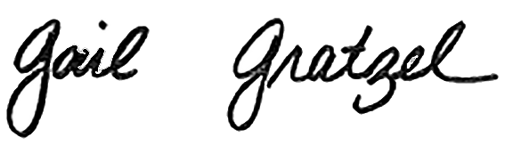
Gail Gratzel, MPH
Assistant Health Officer

